Fill in the gaps with the correct verb forms (Present Perfect)
- John ___________(write) his name.
- I _______________(draw) a picture.
- The cat __________(drink) its milk.
- The tree ________ (fall) across the road.
- John _________ (give) his bicycle to his brother.
- You ____________(make) a mistake.
- We ____________ (eat) our dinner.
- The train _____________(go).
- I ______________(tell) the truth.
- She _____________(buy) bread.

Fill in the gaps with the correct verb forms (Present Simple, Past Simple or Future Simple)
- We ______________ (go) roller-skating last Saturday.
- We _____________ (write) an essay tomorrow.
- I really _____________ (enjoy) the opera yesterday.
- British people _____________ (prefer) tea to coffee.
- Newton _______________ (invent) the telescope in 1668.
- I always _______________ (send) Christmas cards to my grandparents.
- Nina and Nick _____________ (get married) in two weeks.
- Stanley _________________ (have) two sons and a daughter.

Name: _________________________
Surname: ______________________
Class: _________________________

Grammar
Exercises

Fill in the gaps with the correct verb forms (Present Progressive or Past Progressive)
- I __________________ (to write) an English exercise now.
- I __________________ (to write) an English exercise at this time yesterday.
- My little sister ____________ (to sleep) now.
- My little sister ____________ (to sleep) at this time yesterday.
- My friends __________ (not to do) their homework now. They ______________ (to play) volleyball.
- My friends ___________ (not to do) their homework at seven o'clock yesterday. They __________ (to play) volleyball.
- She ____________ (to read) the whole evening yesterday.
- She _____________ (not to read) now.
- Now she _______________ (to go) to school.
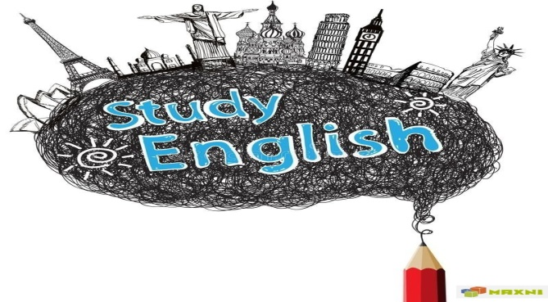
Translate the sentences (Present Progressive)
- Мы пишем. ______________________________
- Они не читают. ______________________________
- Она не работает. ______________________________
- Они не играют на пианино. ______________________________
- Она не поет. ______________________________
- Ее сестра не спит. ______________________________
- Я пишу письмо. ______________________________
- Мальчики не плавают в бассейне. ______________________________
- Моя подруга помогает своему ребенку. ______________________________
- Ученики читают интересную историю. ______________________________
- Они читают книгу. ______________________________

Fill in the gaps with the correct verb forms (to be going to)
1. Mary ______________ (present) me a book for Christmas.
2. John’s brother ______________ (not/take) his exam this year.
3. Miss Smith (sing) after dinner. ______________________________
4. The government (build) a new hospital near here. ______________________________
5. He (live) in a warm climate when he retires. ______________________
6. They (get married) in the spring. ______________________________
7. The Browns (sell) their house at the end of the year. ______________________________

Translate into English using “to be going to”
  - Я собираюсь пойти в кинотеатр. ________________________
  - Она собирается написать новую книгу. ________________________
  - Дети не собираются играть в компьютер. ________________________

