Составьте из слов вопросы:
- he, has, a brother, got?
__________________________
- a parrot, she, has, got?
__________________________
- got, a grandma, you, have?
__________________________
- Alice, a fox, got, has?
__________________________
Переведите на русский язык:
- She has got a father.
__________________________
- I have got a mother.
__________________________
- We have got a cat.
__________________________

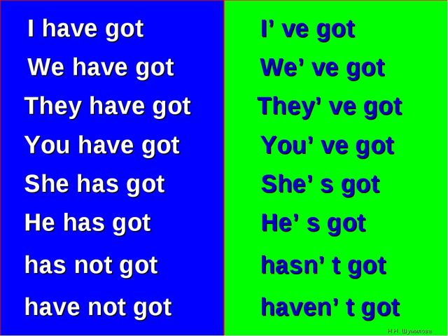
Перепишите предложения, используя краткую форму
- You have not got a mother. ________________________
- She has not got a brother.
________________________
- He has got a cat.
________________________
Переведите на английский язык:
- У меня есть брат.
________________________
- У неё есть кот
________________________
- У нас есть семья.
________________________

Name: ____________________
Surname: _________________
Class: ____________________

Have got/ has got exercises
(упражнения на глагол have got/has got)

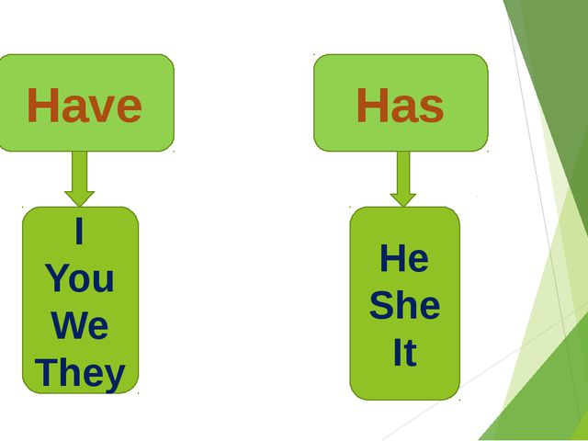
Напишите строчку:
- have ___________________
_________________________
- has ____________________
__________________________
- got____________________
_________________________
Вставьте have got или has got:
- We ______ ______ a dog.
- They ______ ______ a grandmother.
- He _____ _____ a sister.
- I _______ _____ a family
- Kate _____ ______ a brother.
- Mike _____ _____ a cat.
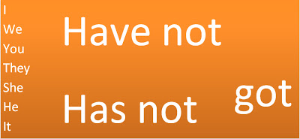
Сделайте предложения отрицательными:
- I have got a sister.
__________________________
- Bob has got a father.
__________________________
- They have got two sisters.
__________________________
- She has got three brothers.
__________________________
- You have got a brother.
__________________________
- We have got friends.
__________________________
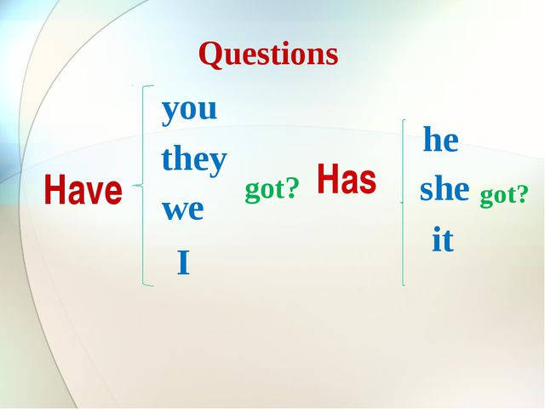
Напишите вопросительные предложения:
- Ann has got a cat.
__________________________
- Bob has got a rabbit.
__________________________
- They have got a sister.
__________________________
- You have got a grandmother.
__________________________
- I have got a brother.
__________________________

